Azure DevOps Setup Manual

Contents

Setup your Azure DevOps 2

1.1. Fresh AzureDevOps Login 2

1.2. Setup a new Organization in existing Azure DevOps Account 6

Please Setup your Azure DevOps Account before the Hackathon and feel free to Contact us if you need any Help during the Process.

Setup your Azure DevOps

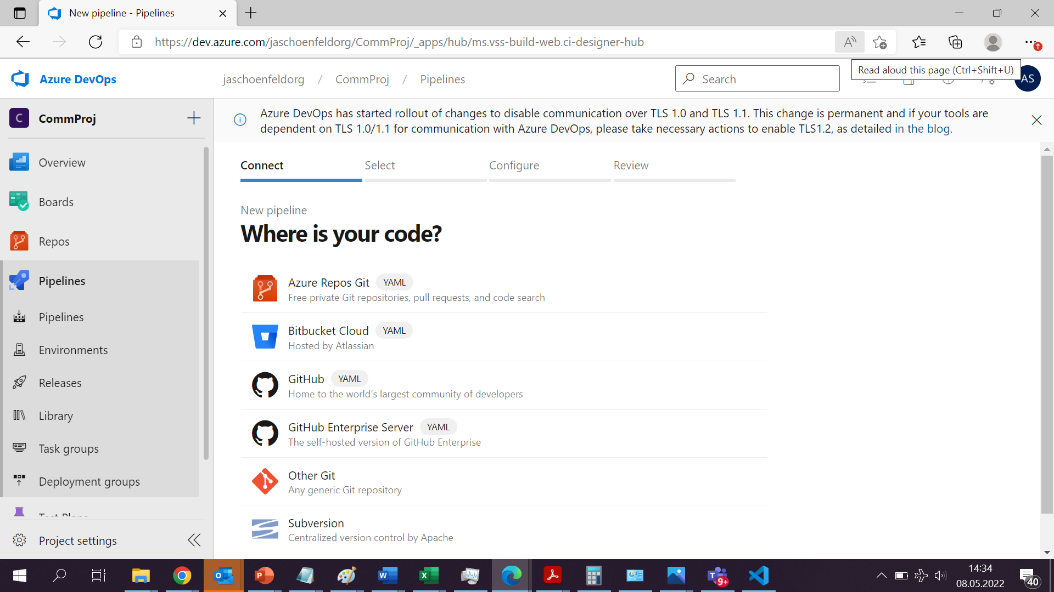

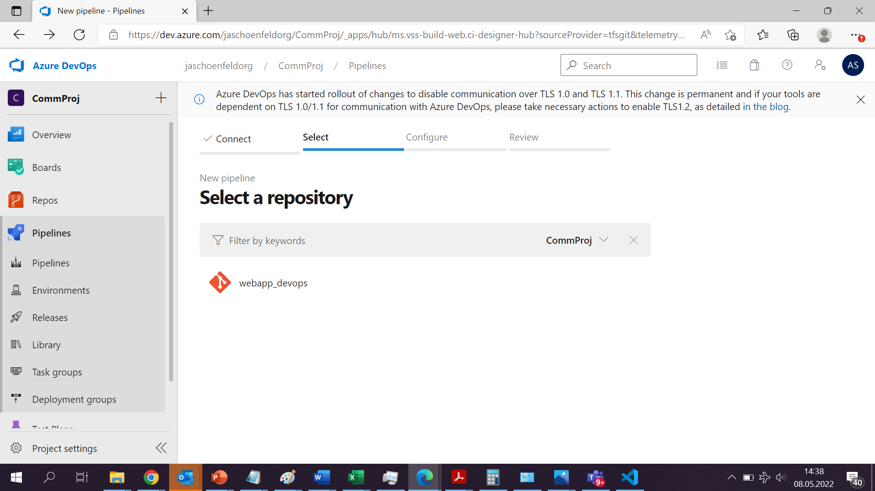

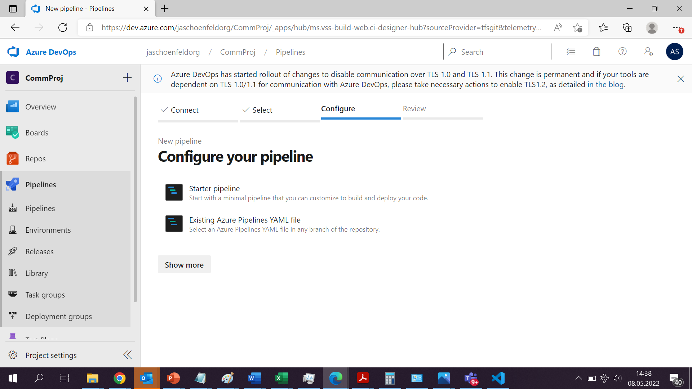

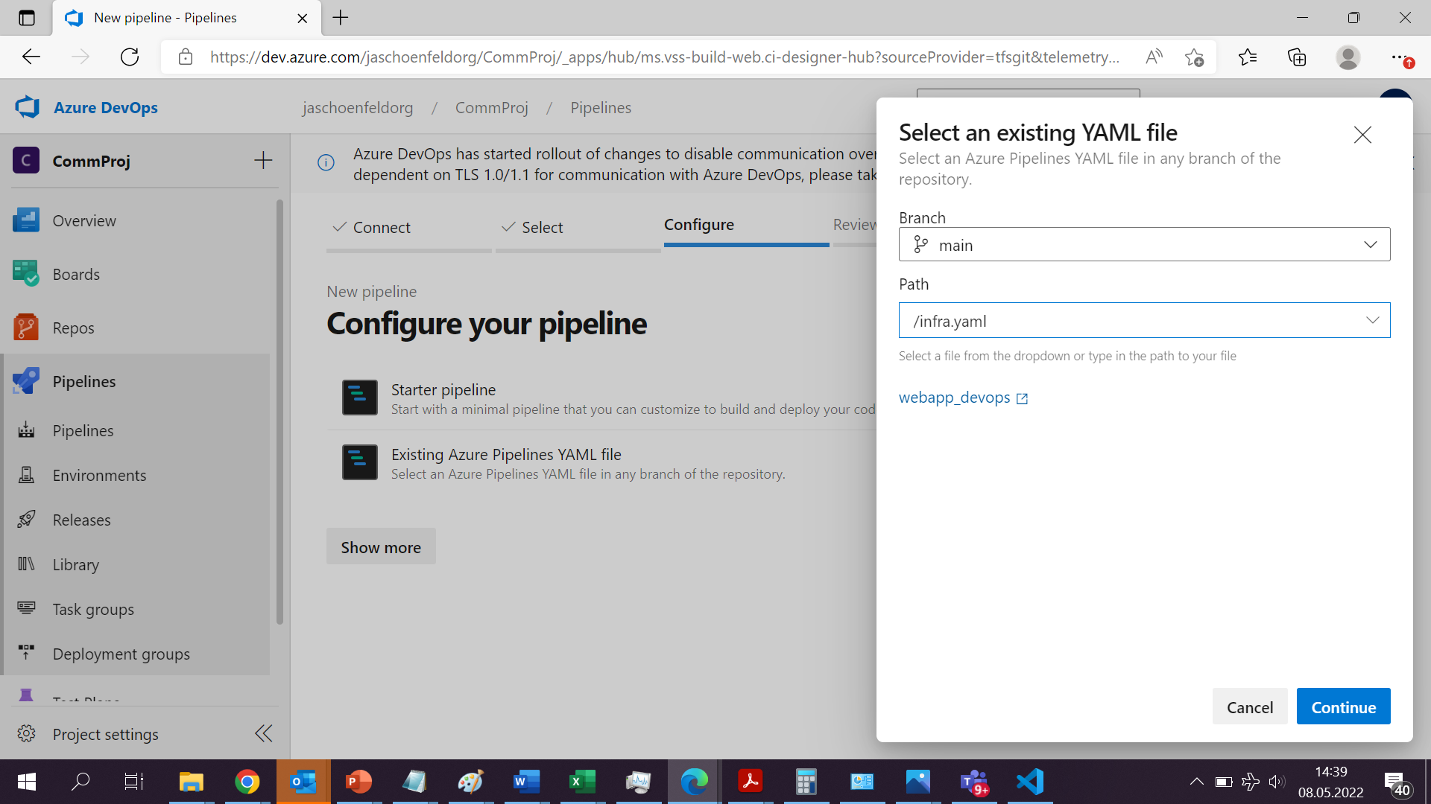

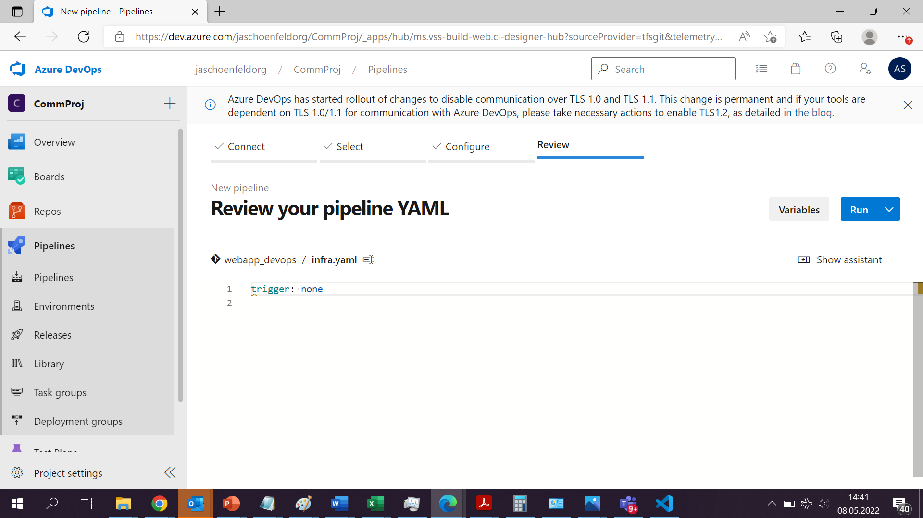

* 1. Fresh AzureDevOps Login

If you never Used Azure Devops before use this one.

1. Login to your Capgemini Account under <https://dev.azure.com/>

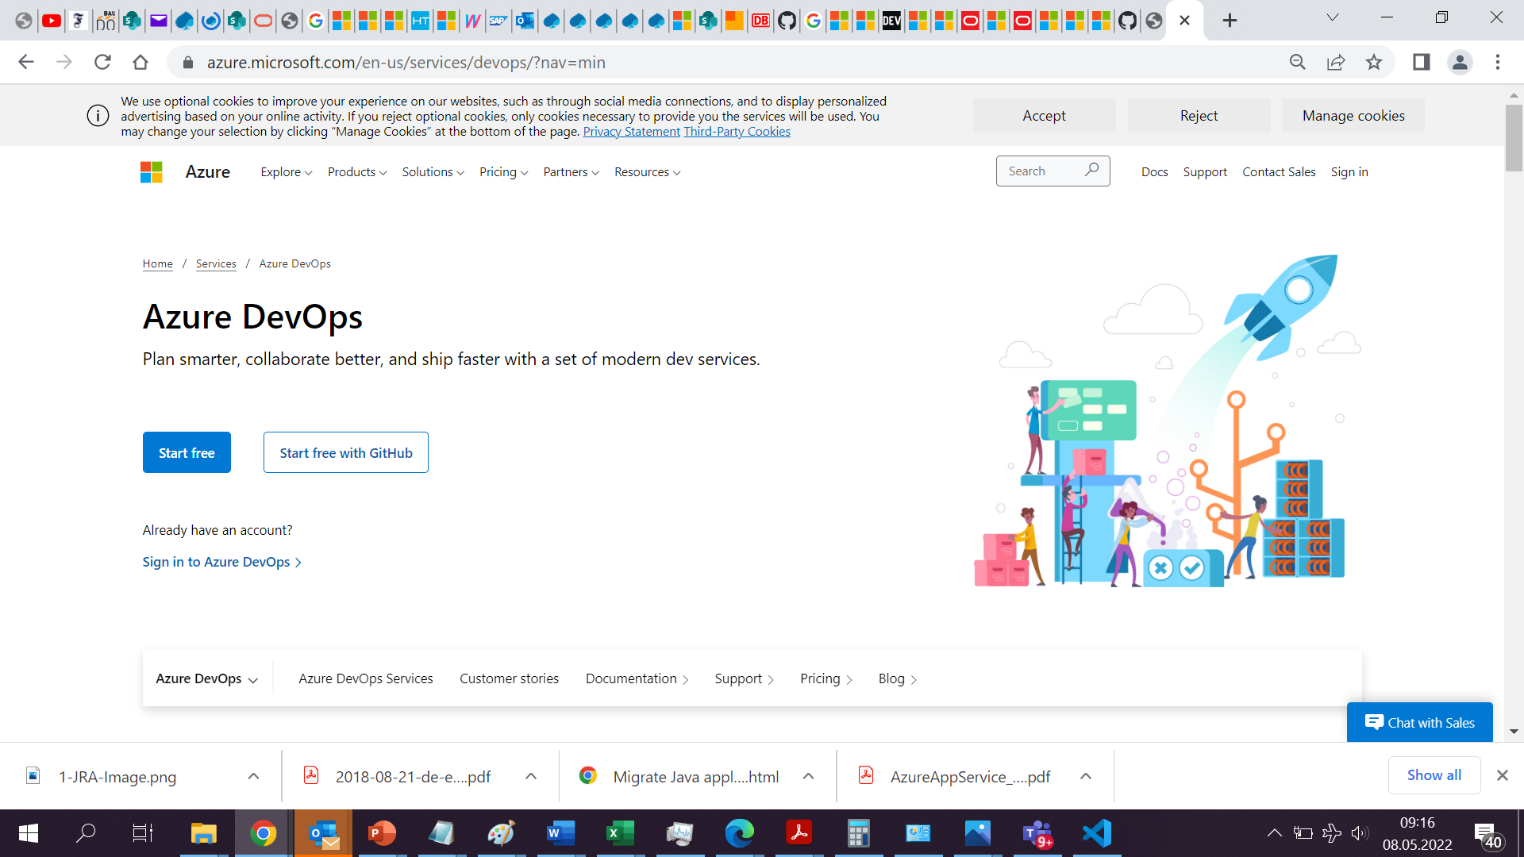

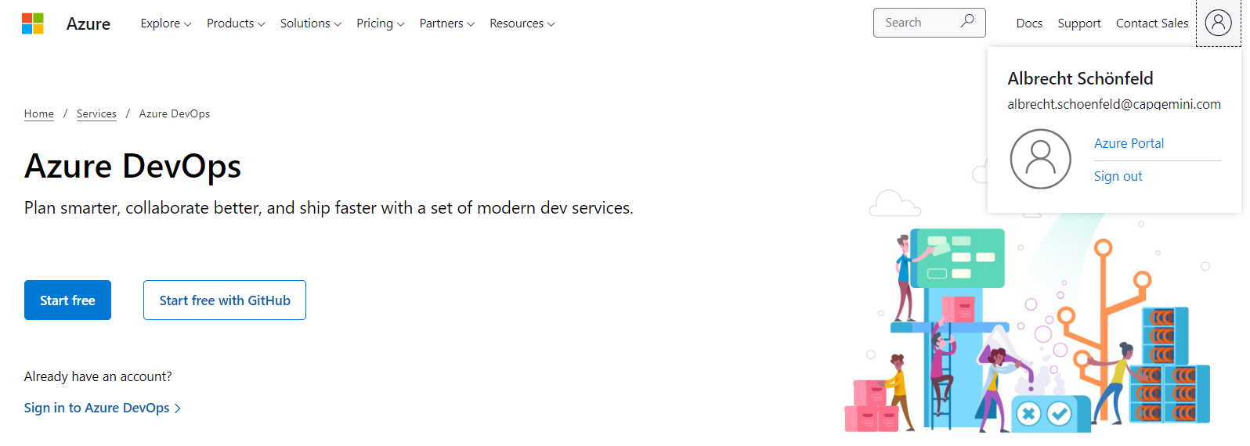

1. If you are Already Logged in Skip the Next Step
   1. Click “Sign in” on the Top Right Corner  
      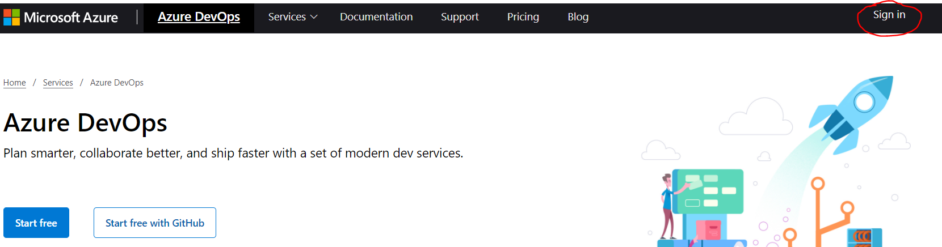
   2. Select your Organisation Account or enter your Company Mail Address  
      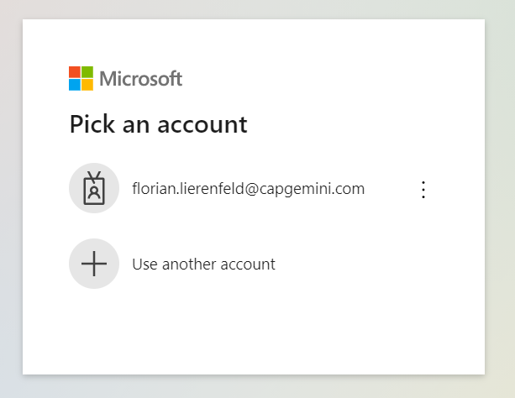
   3. You are Redirected to Capgemini Login  
      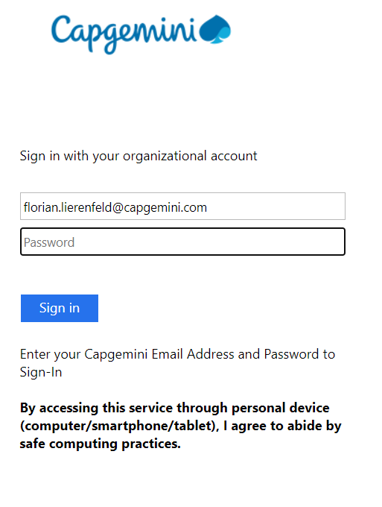
2. When you are Successfully Signed in you are Redirected to <https://dev.azure.com> again where you can select “Start Free”  
   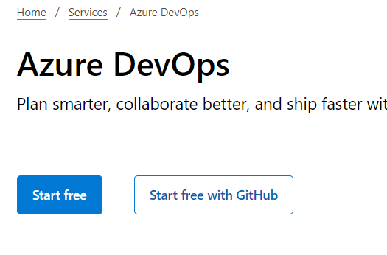
3. Next you can Setup your Azure DevOps Account  
   Select a Unique Name for your Project, Set it to Private and enter the Capture.  
   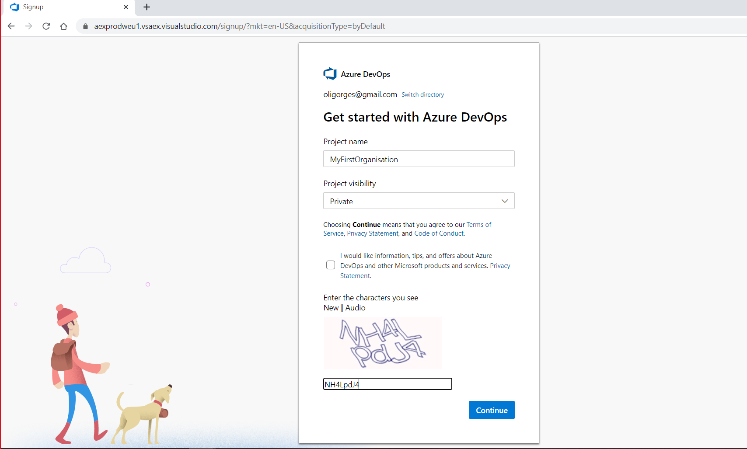
4. Your Project will be Created  
   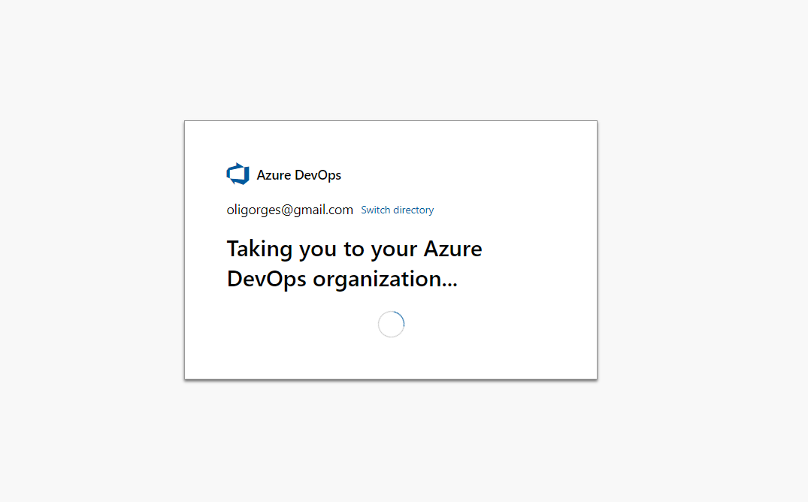
5. Your Organisation is now Setup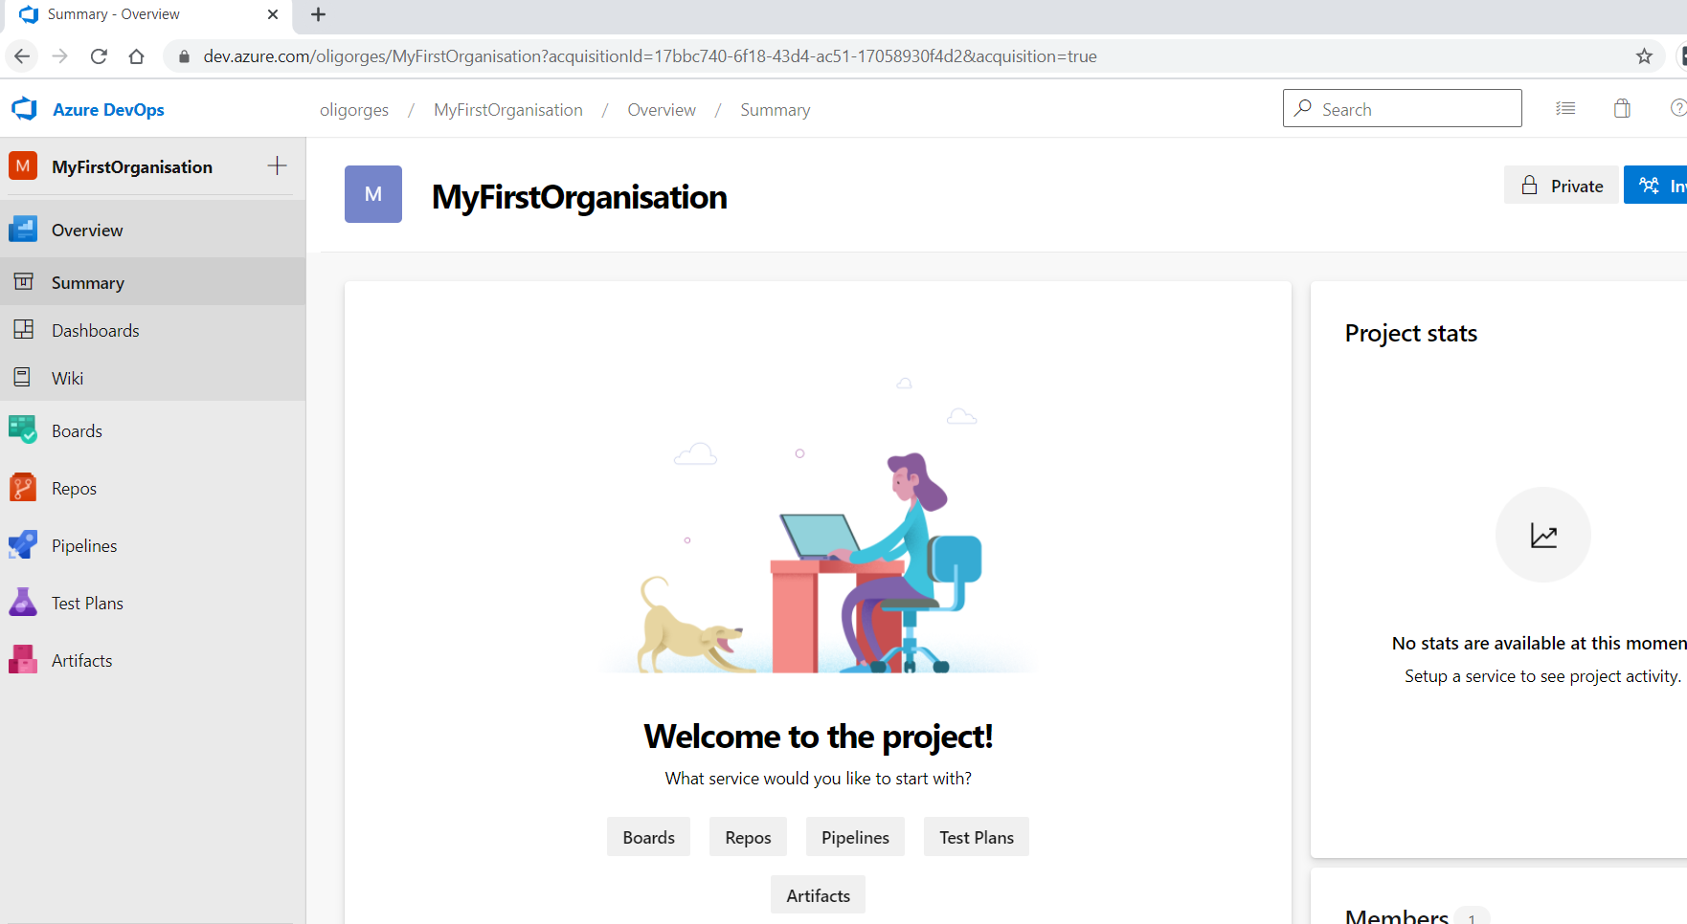
   1. Setup a new Organization in existing Azure DevOps Account

If you used Azure Devops before and don’t have your own Organization Setup, you can Login at <https://dev.azure.com> and Select “Create new Organization” on the Right side.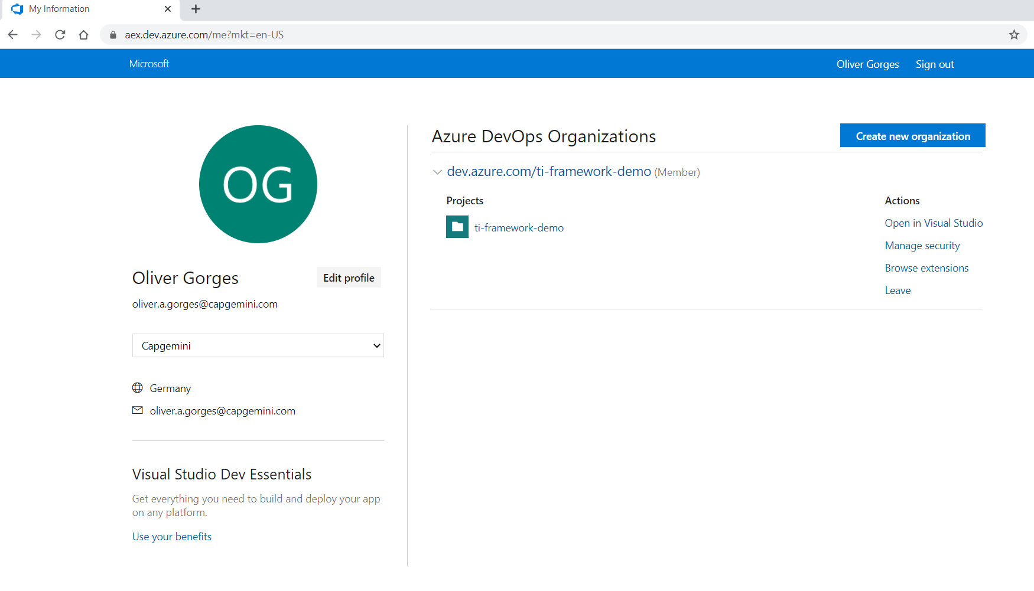

1. Click “Continue”  
   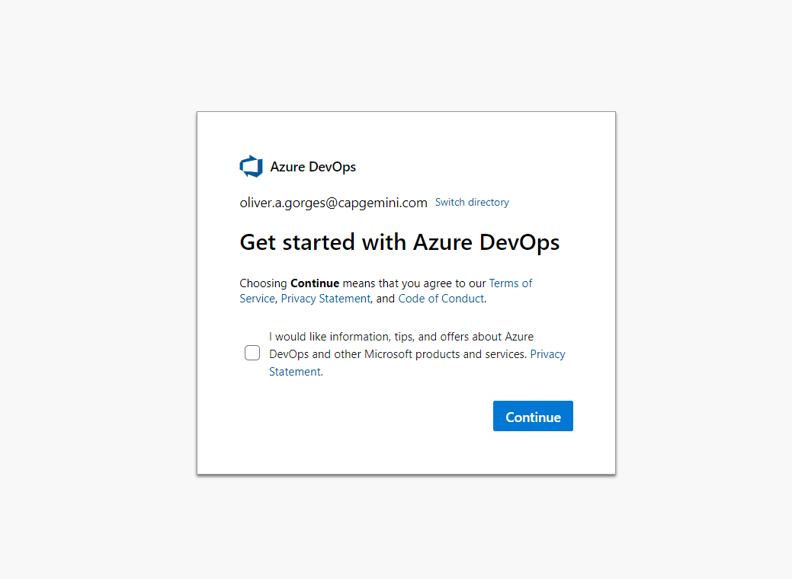
2. Select a unique Name for your Organization and Select a Region next to you.  
   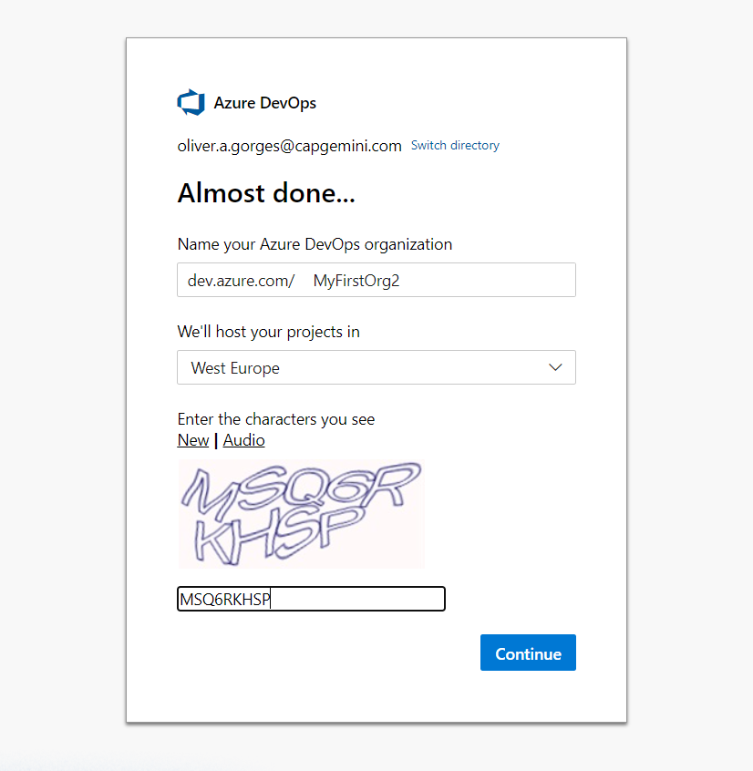
3. Your Organization is Setup  
   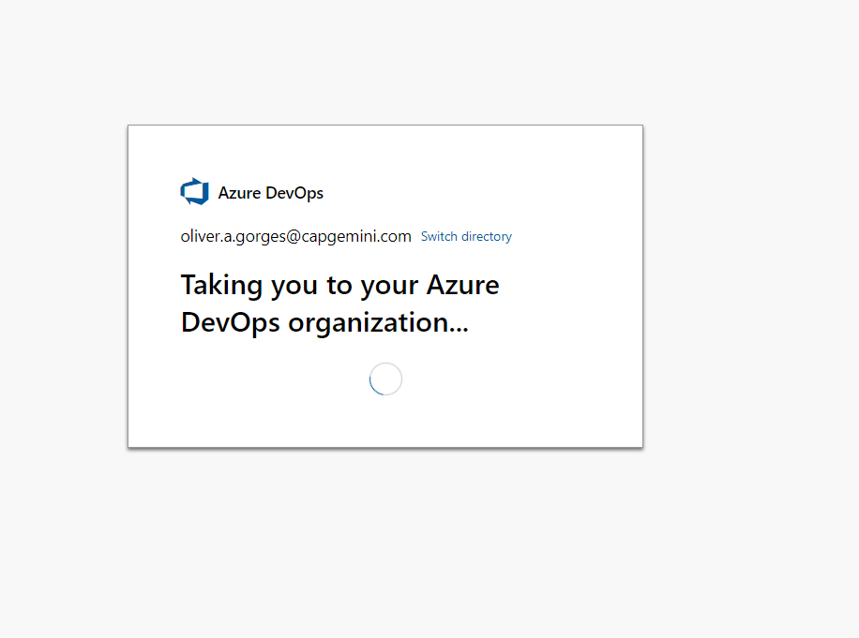
4. Create your first Project  
   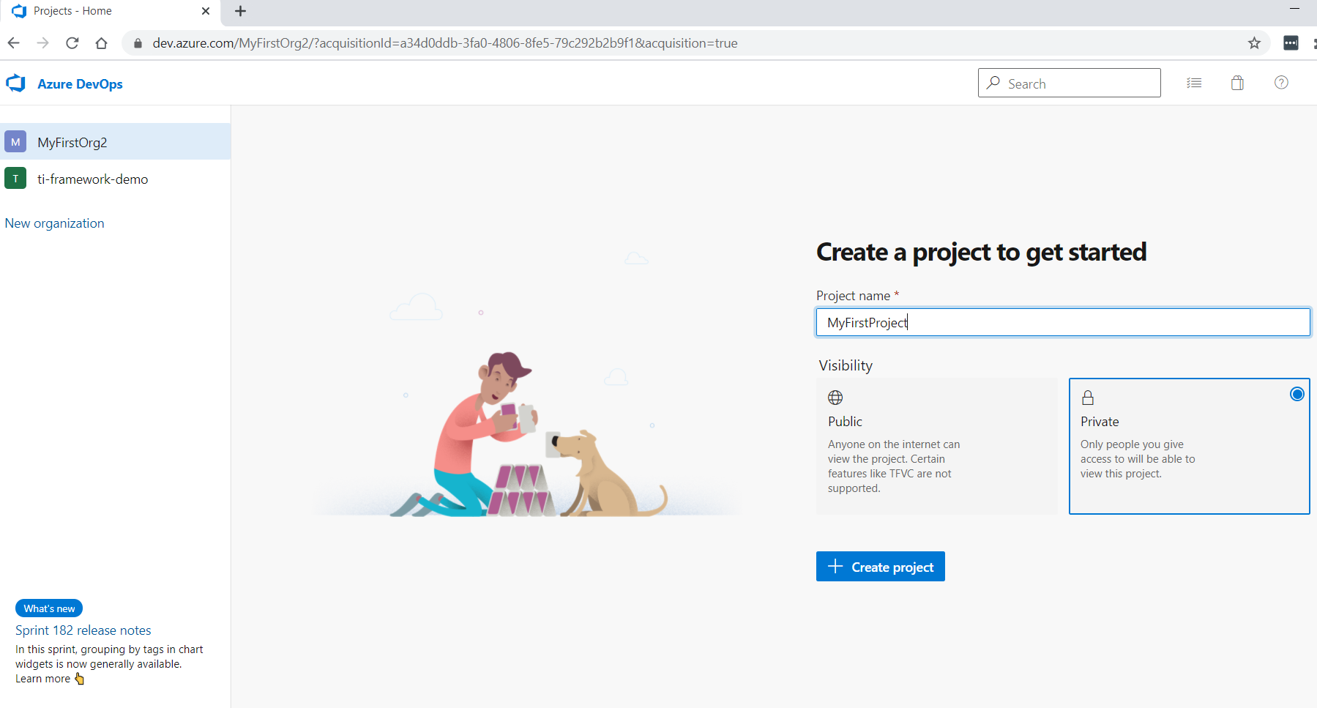
5. Your Site is Setup  
   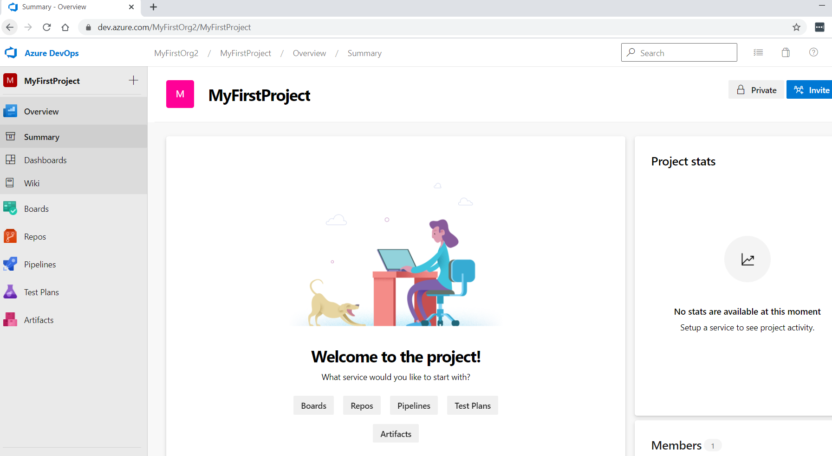

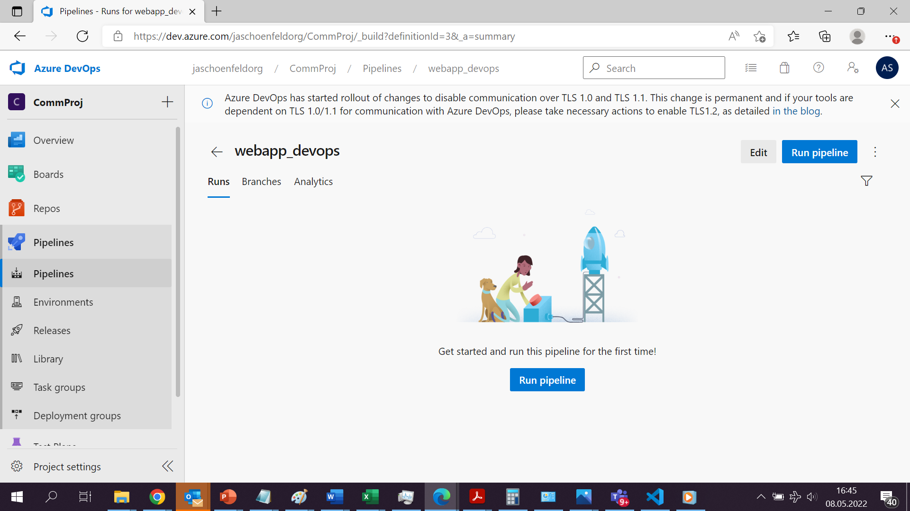

Wichtige Links:

* MEC: <https://azure.microsoft.com/en-us/solutions/private-multi-access-edge-compute-mec/#overview>
* Azure Stack: <https://azure.microsoft.com/en-us/overview/azure-stack/#overview>

Warum passt es:

* Provide required technology from hardware and software perspective to provide an intelligent edge integrated with the cloud
* Offerings are ranging from integrated solutions to dedicated building blocks providing edge relevant functionality (e.g. Azure Stack HCI as integrated solutions with Cloud Integration and Azure Arc support or use the power of pretrained models from cognitive services that only require Azure IoT Edge as software runtime)

Warum CapGemini;

* With its organizational units (invent etc) can cover end-to-end to turn data into business value
* It’s own platforms like ENSCONCE are based on long experience and especially geared to consider cloud agnostic approaches
* An example is the Nexeed platform where CapGemini supports as strategic partner from the integration of existing plants and intelligent maintenance solutions to the networking of complete factories. The solutions from the Nexeed Industrial Application System are already being used successfully in more than half of the approximately 240 Bosch plants worldwide, and the trend is rising.

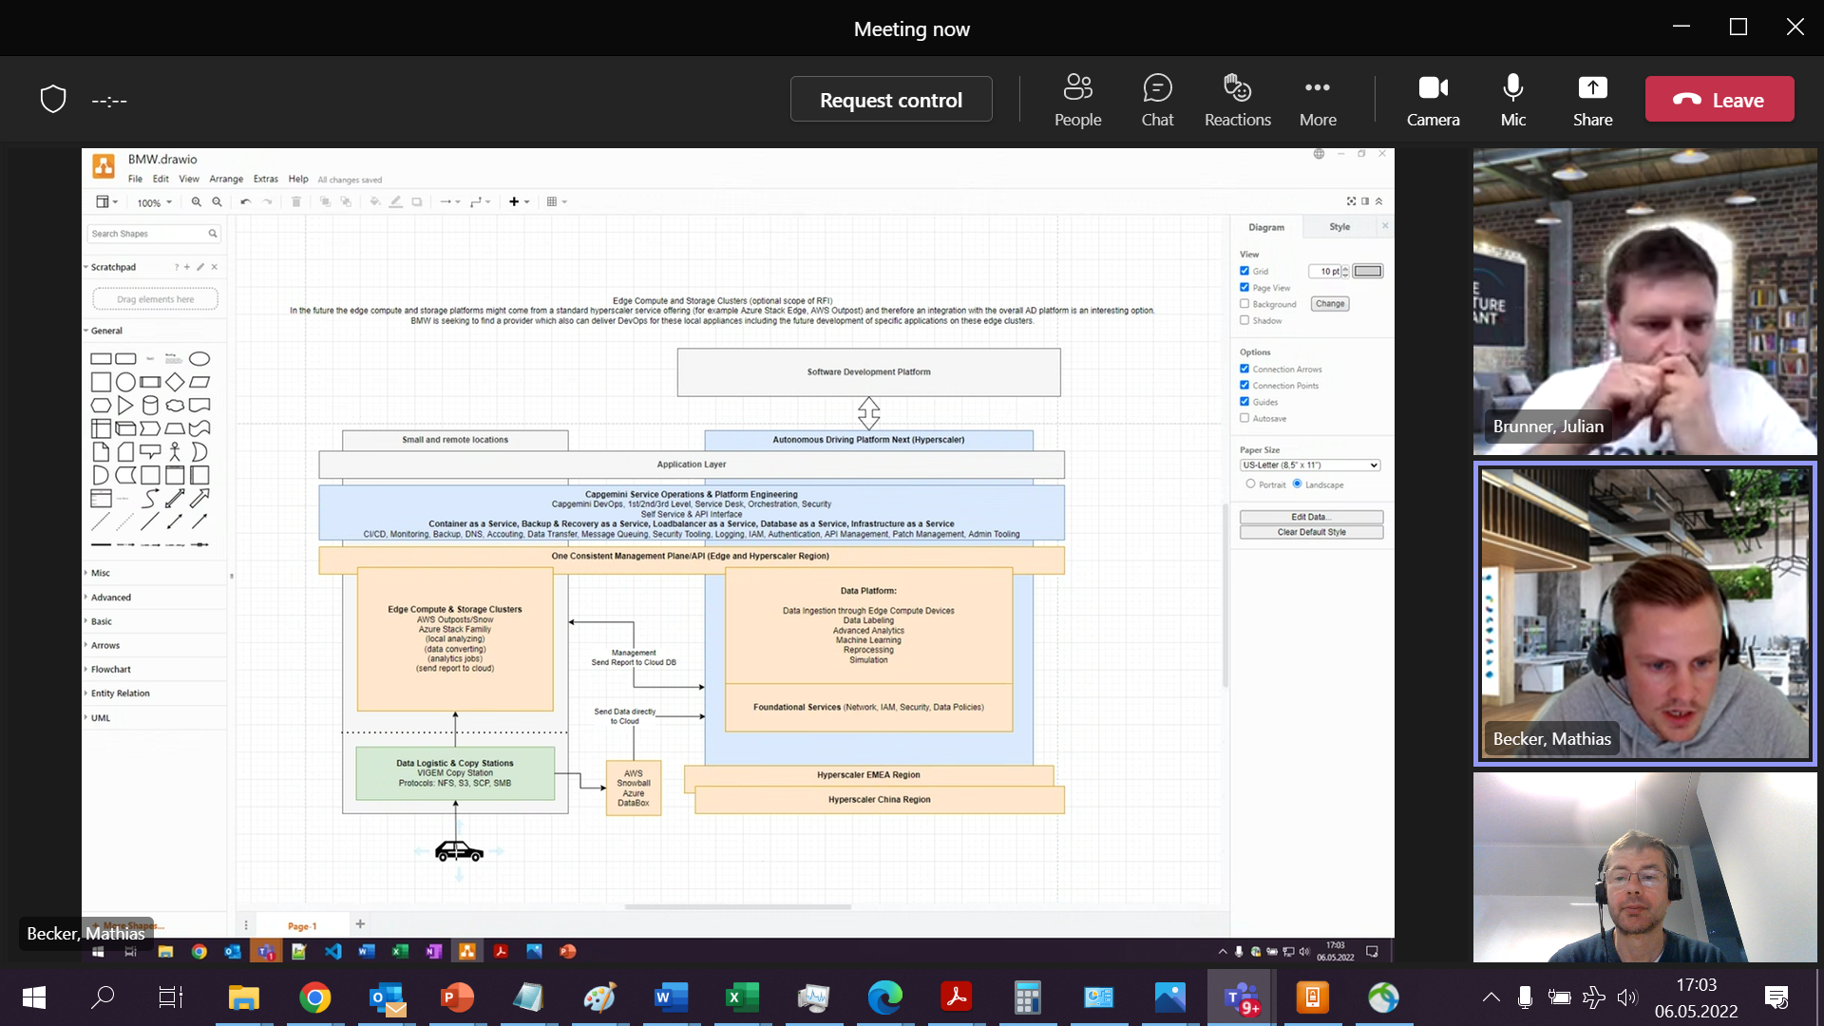

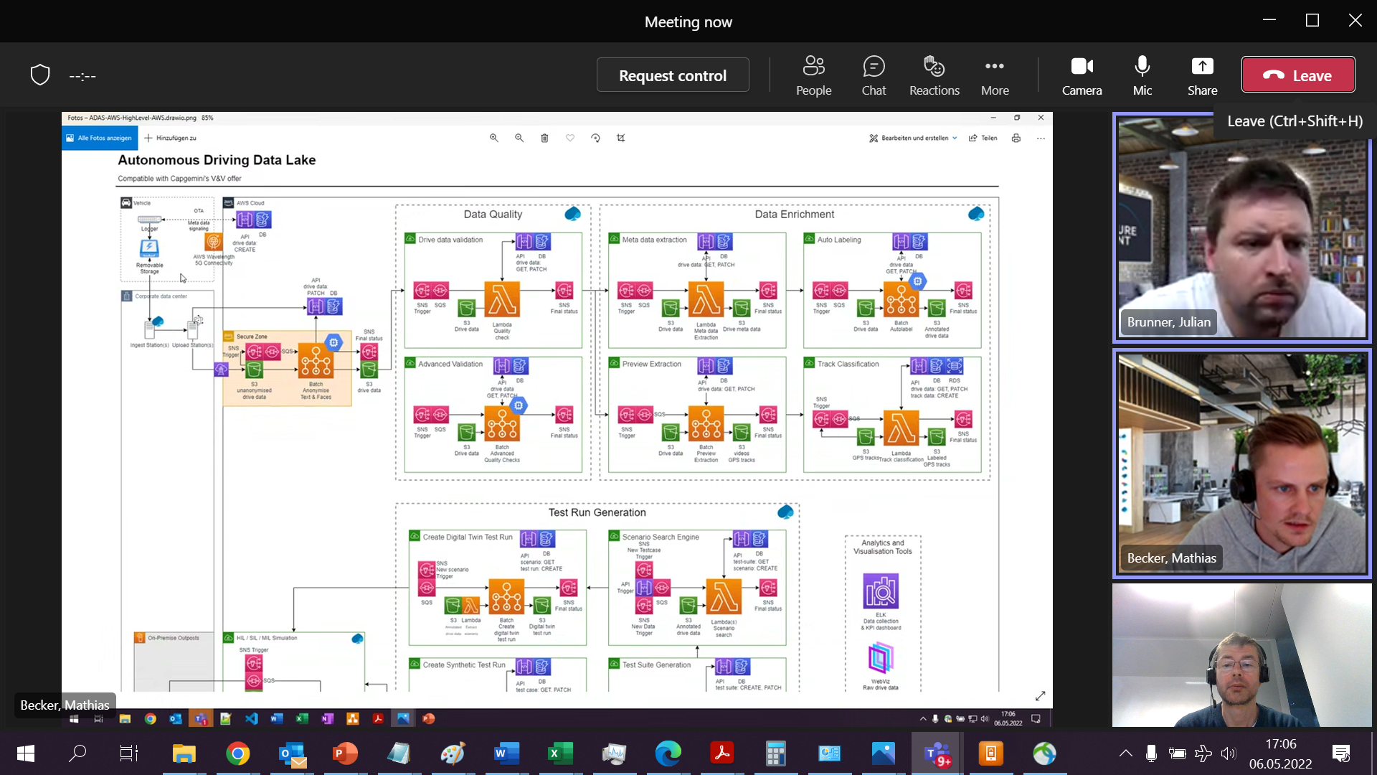

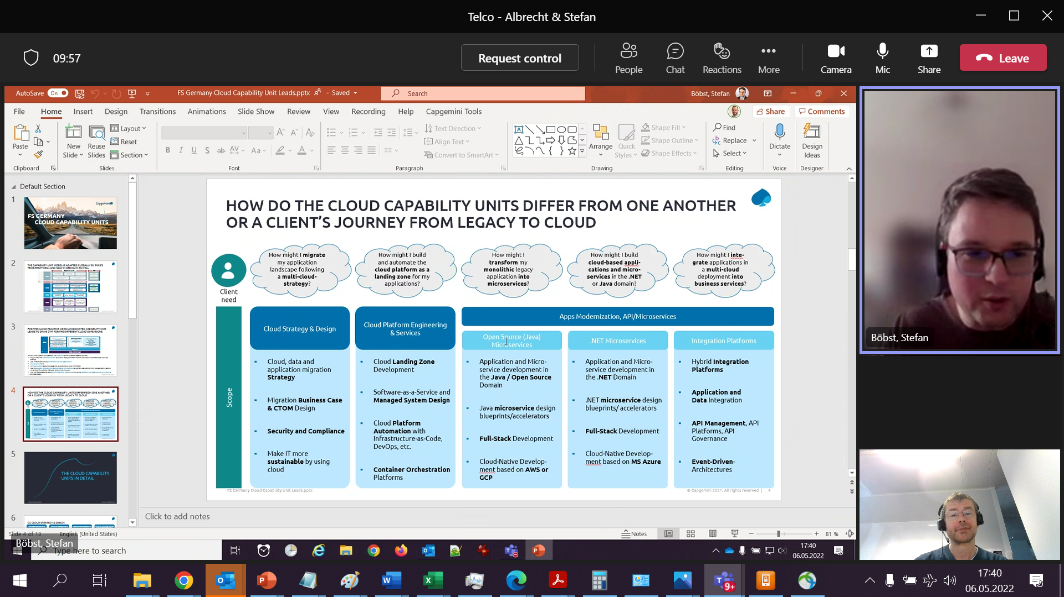

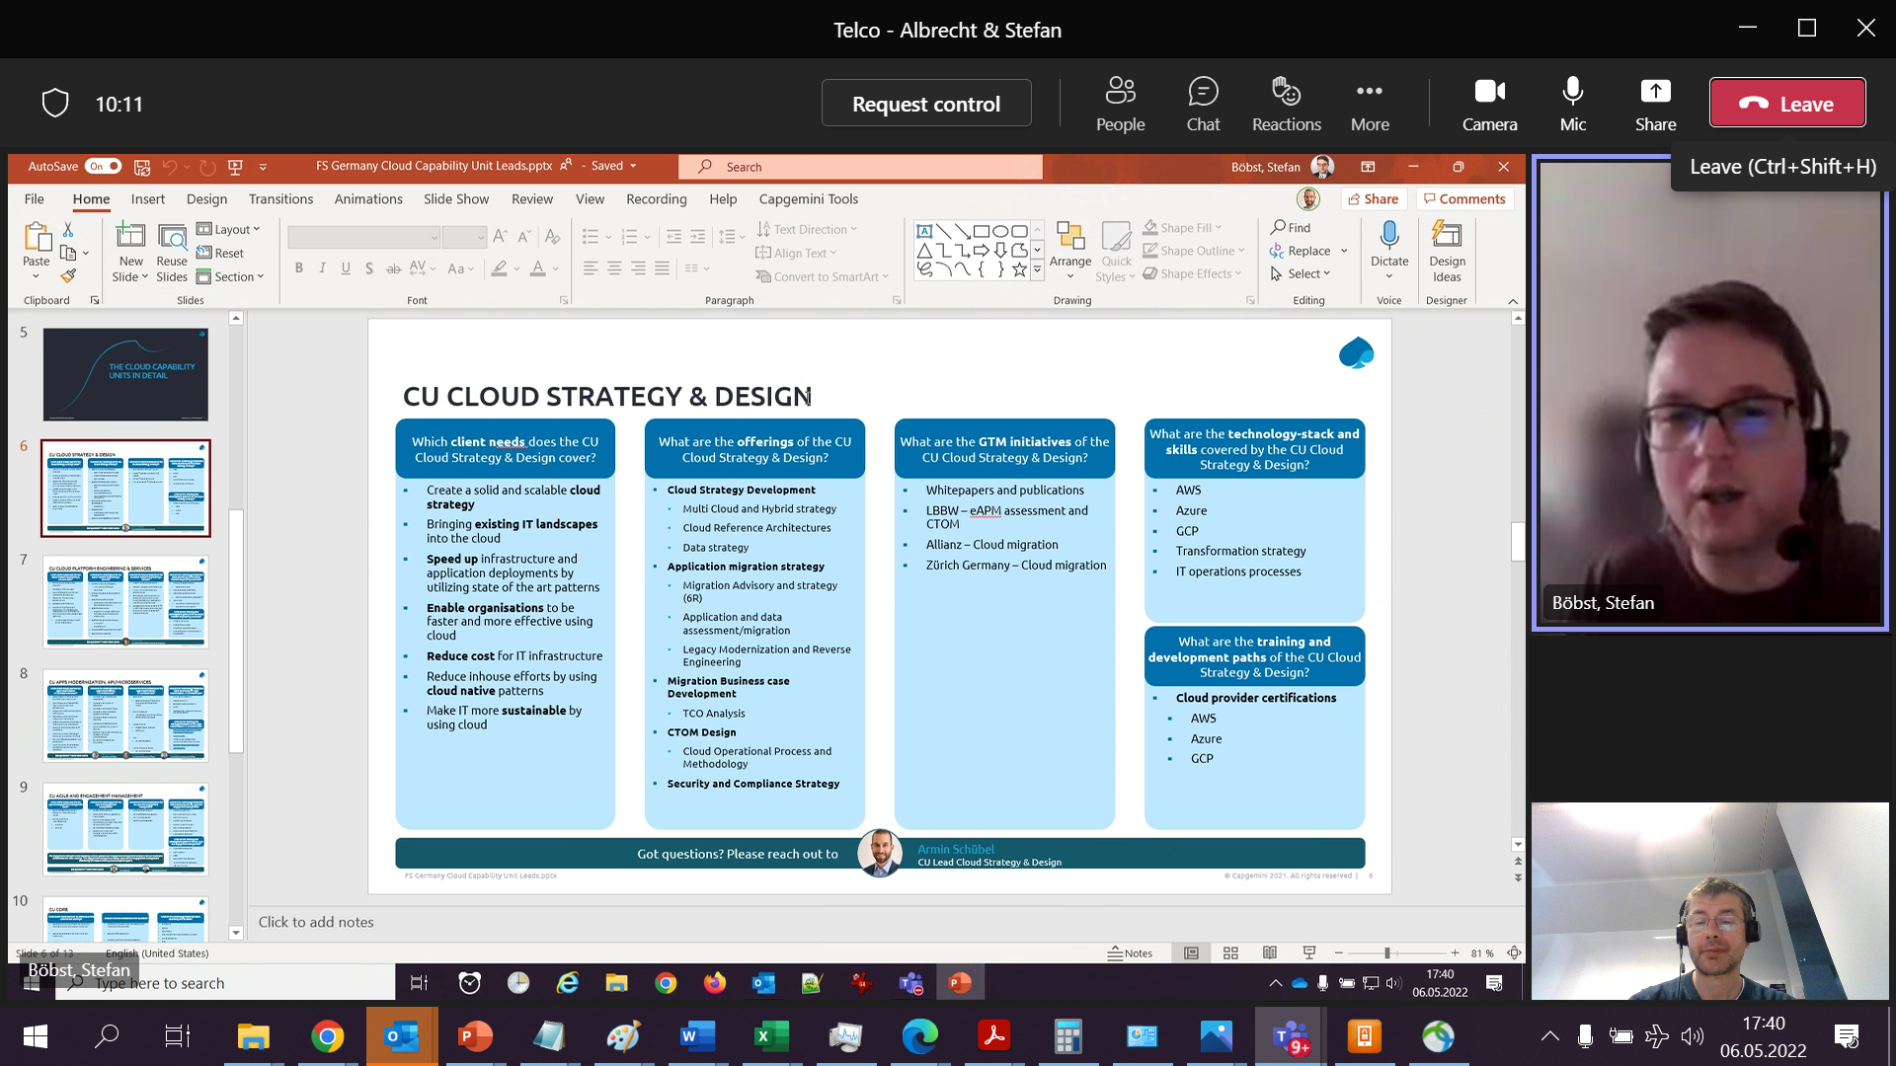

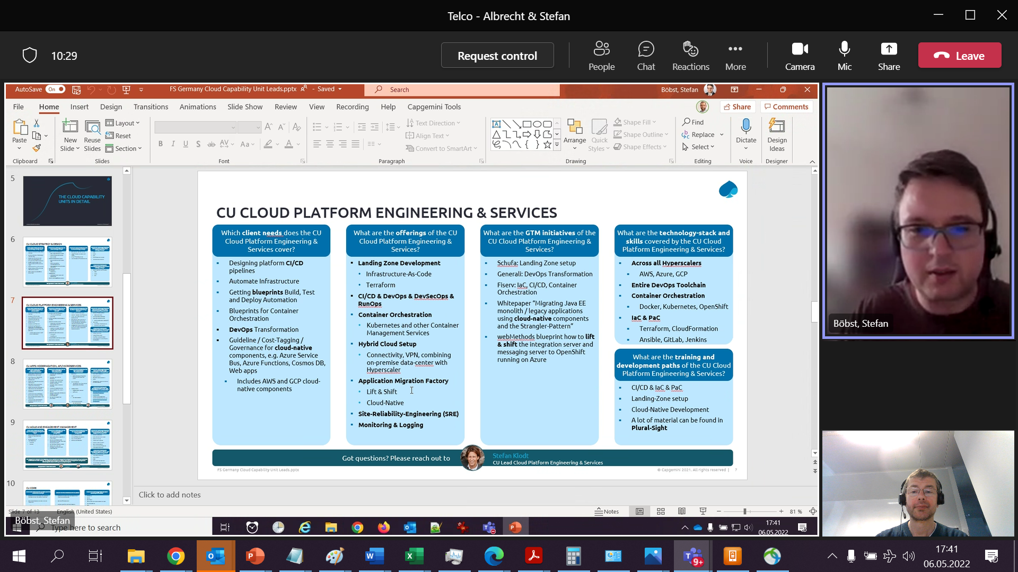

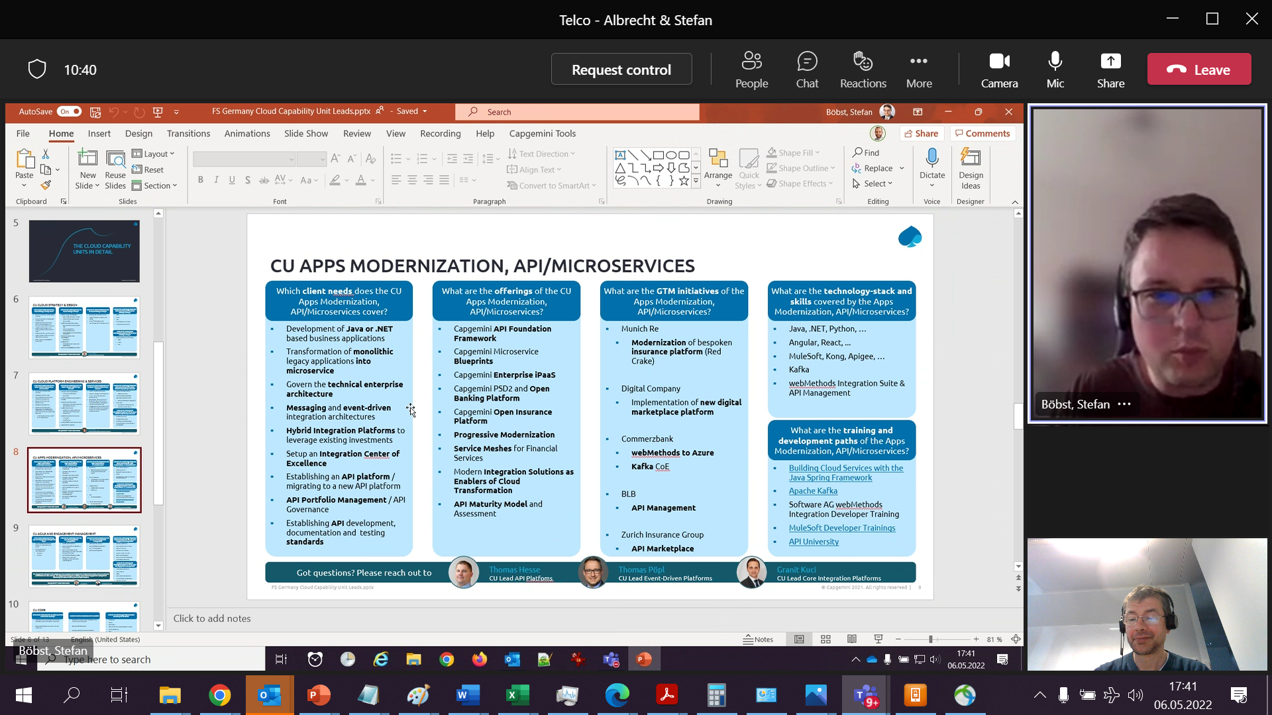

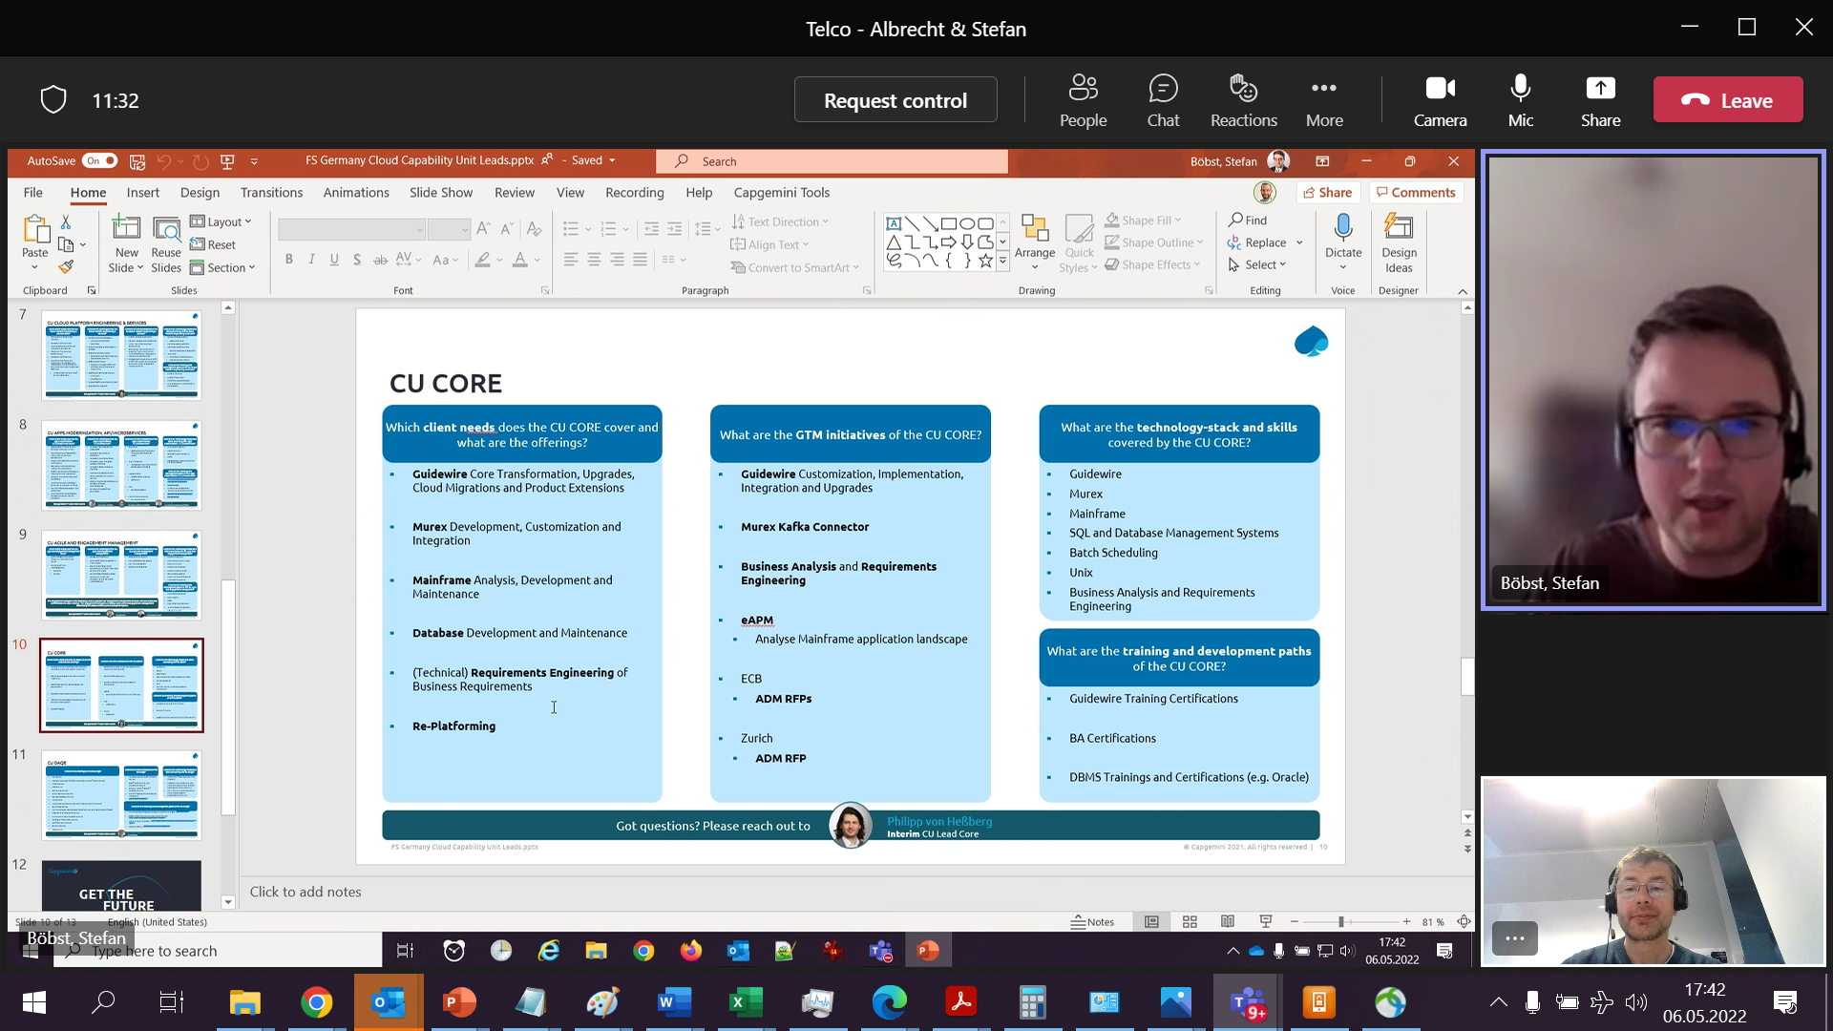

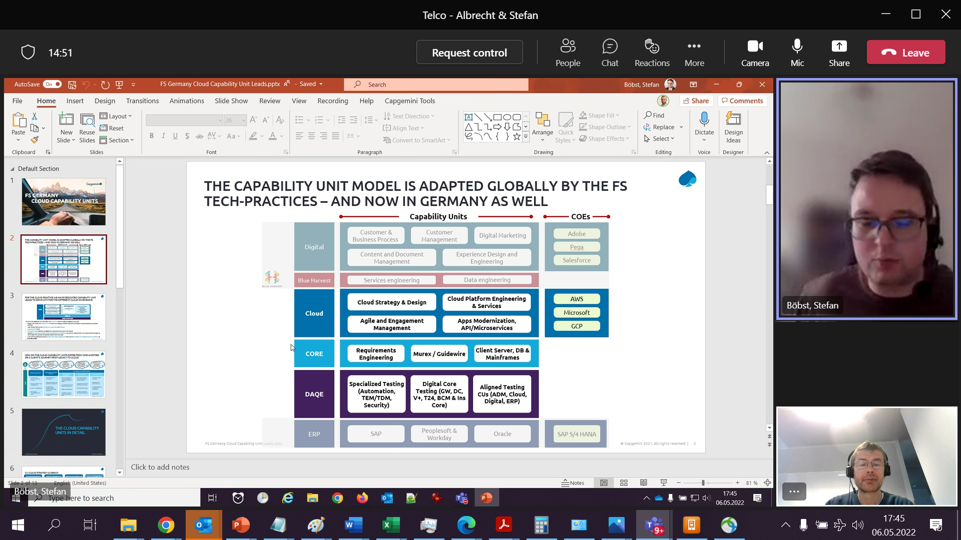

* What are major building blocks: centralized cloud management (Arc), out of the box AI support for custom models (e.g. Azure Stack Edge), standardized software platform to run your own logic including cloud connect (Azure IoT Edge e.g. with containerized Cognitive Services)
* Platforms also allow agnostic platforms such as kubernetes

Warum CapGemini;

* With its organizational units (invent etc) can cover end-to-end to turn data into business value
* If possible without cloud provider specifics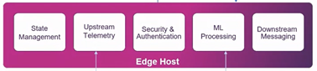
* Altran long expertise of providing solutions for these challenges komplette PLattformen
* Nexceed

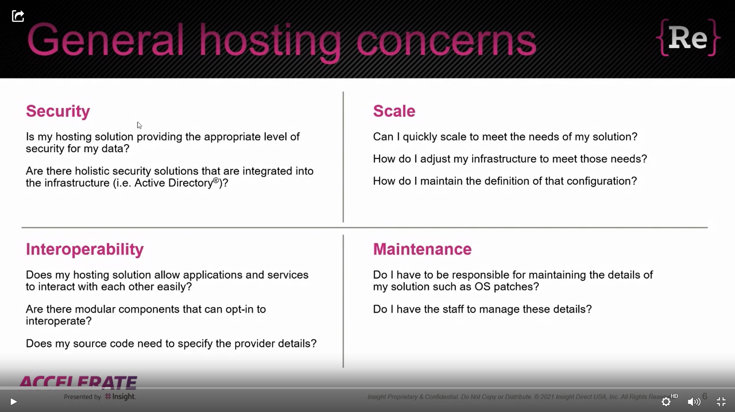

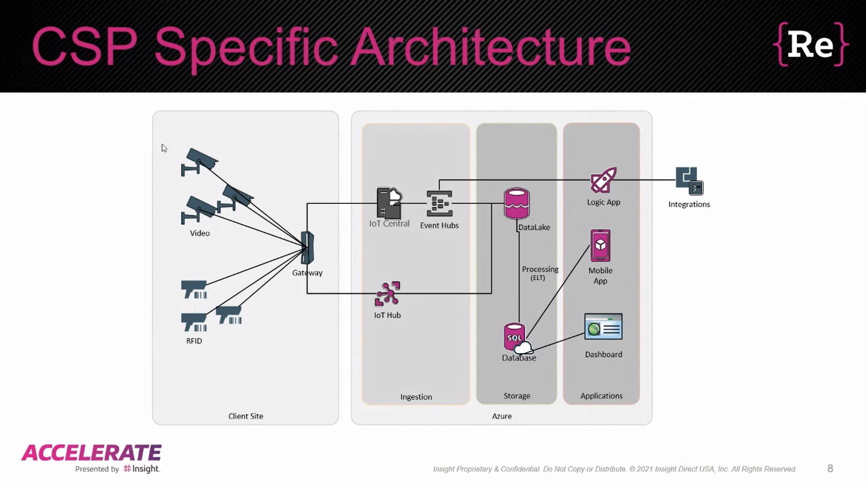

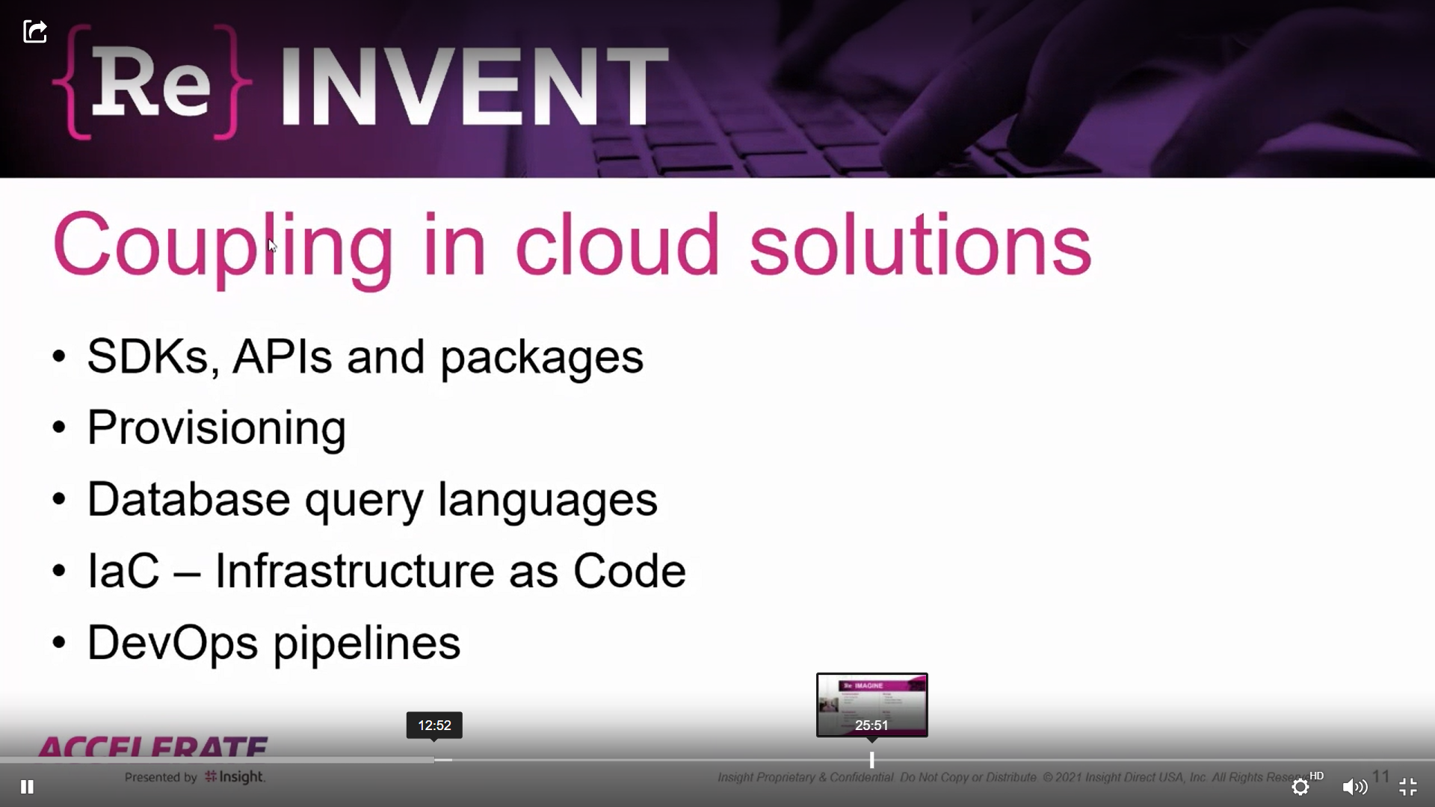

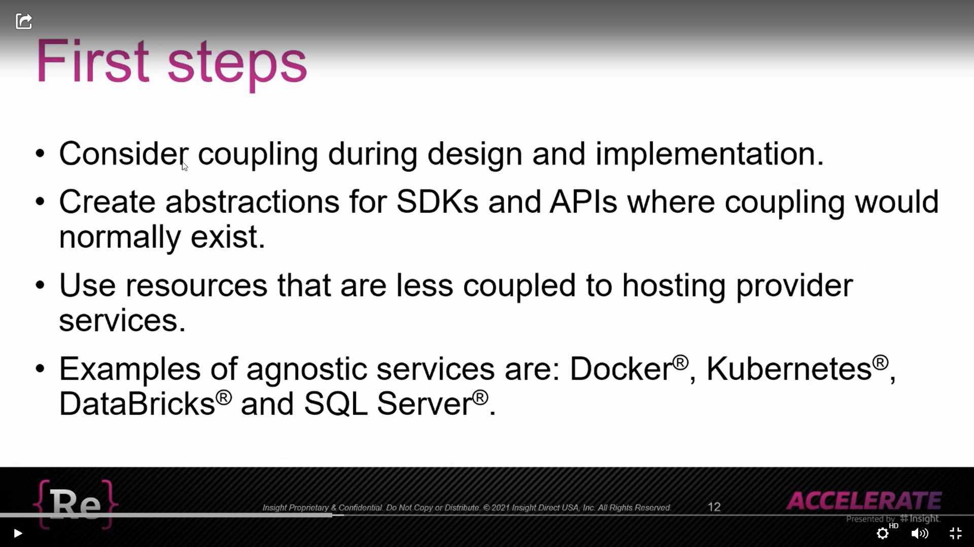

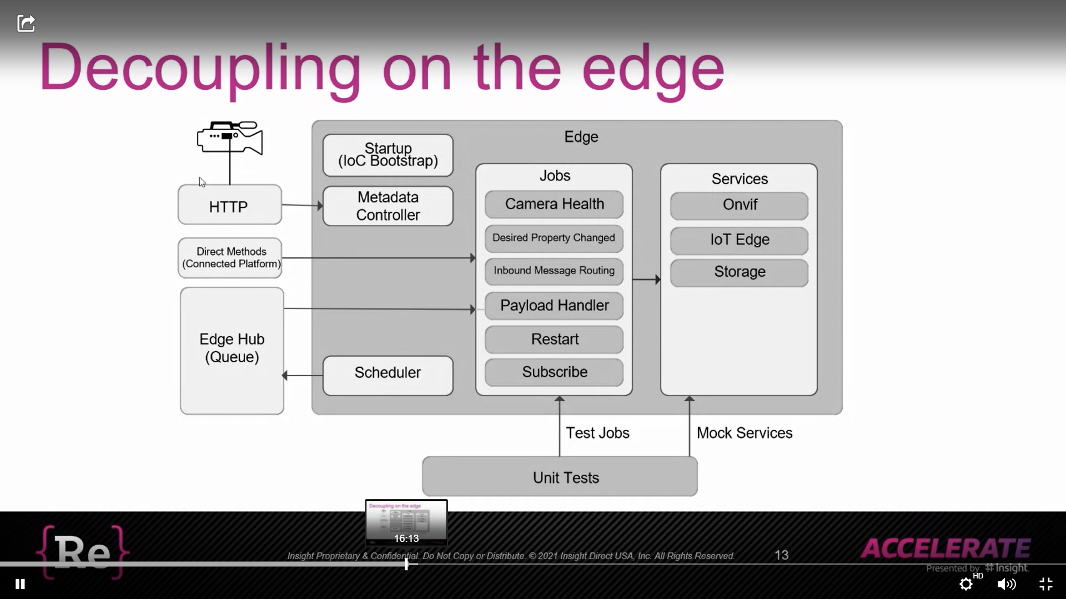

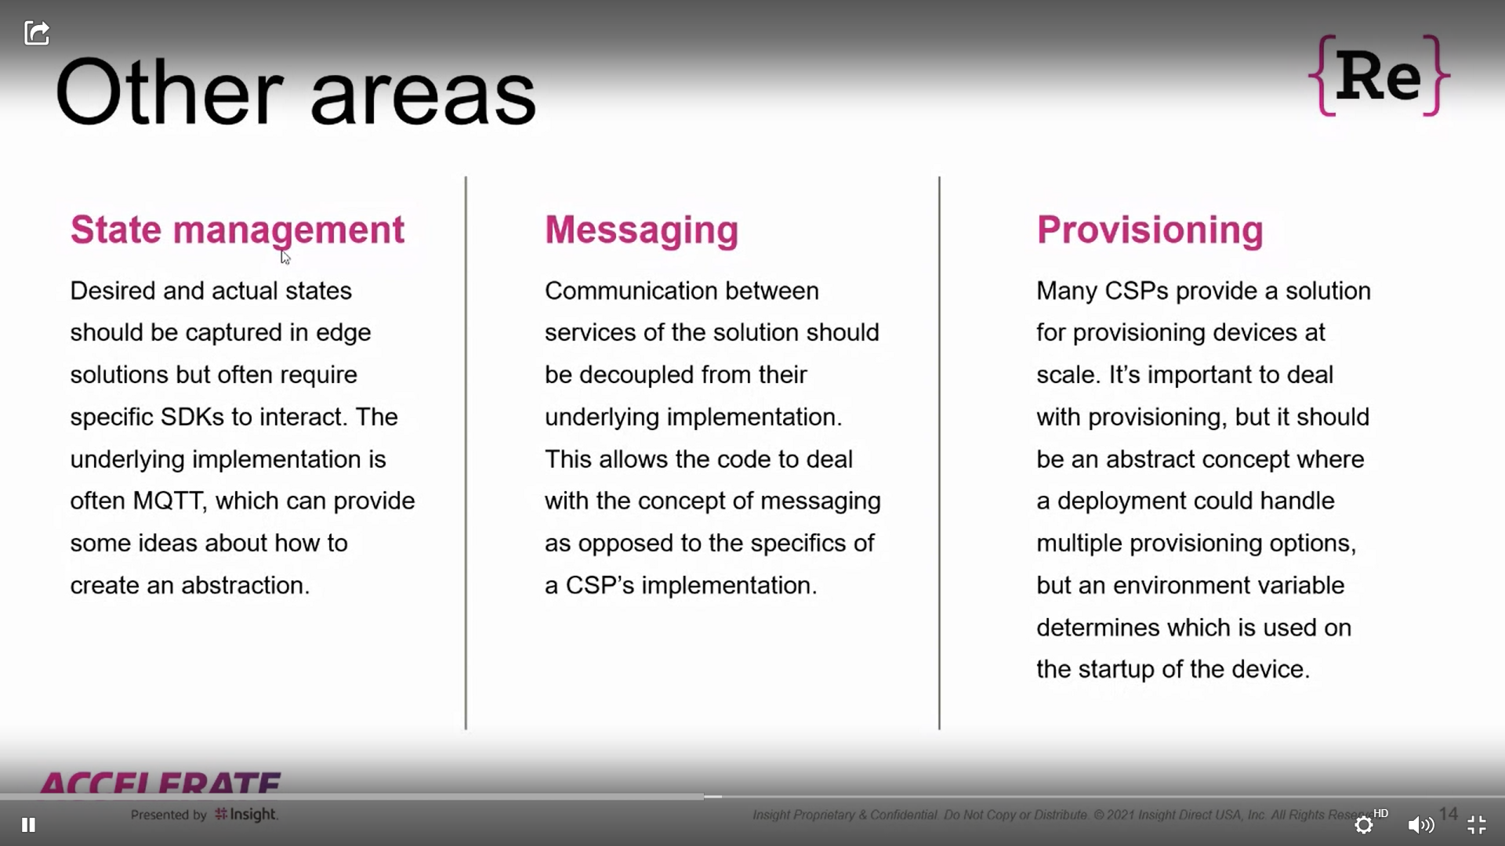

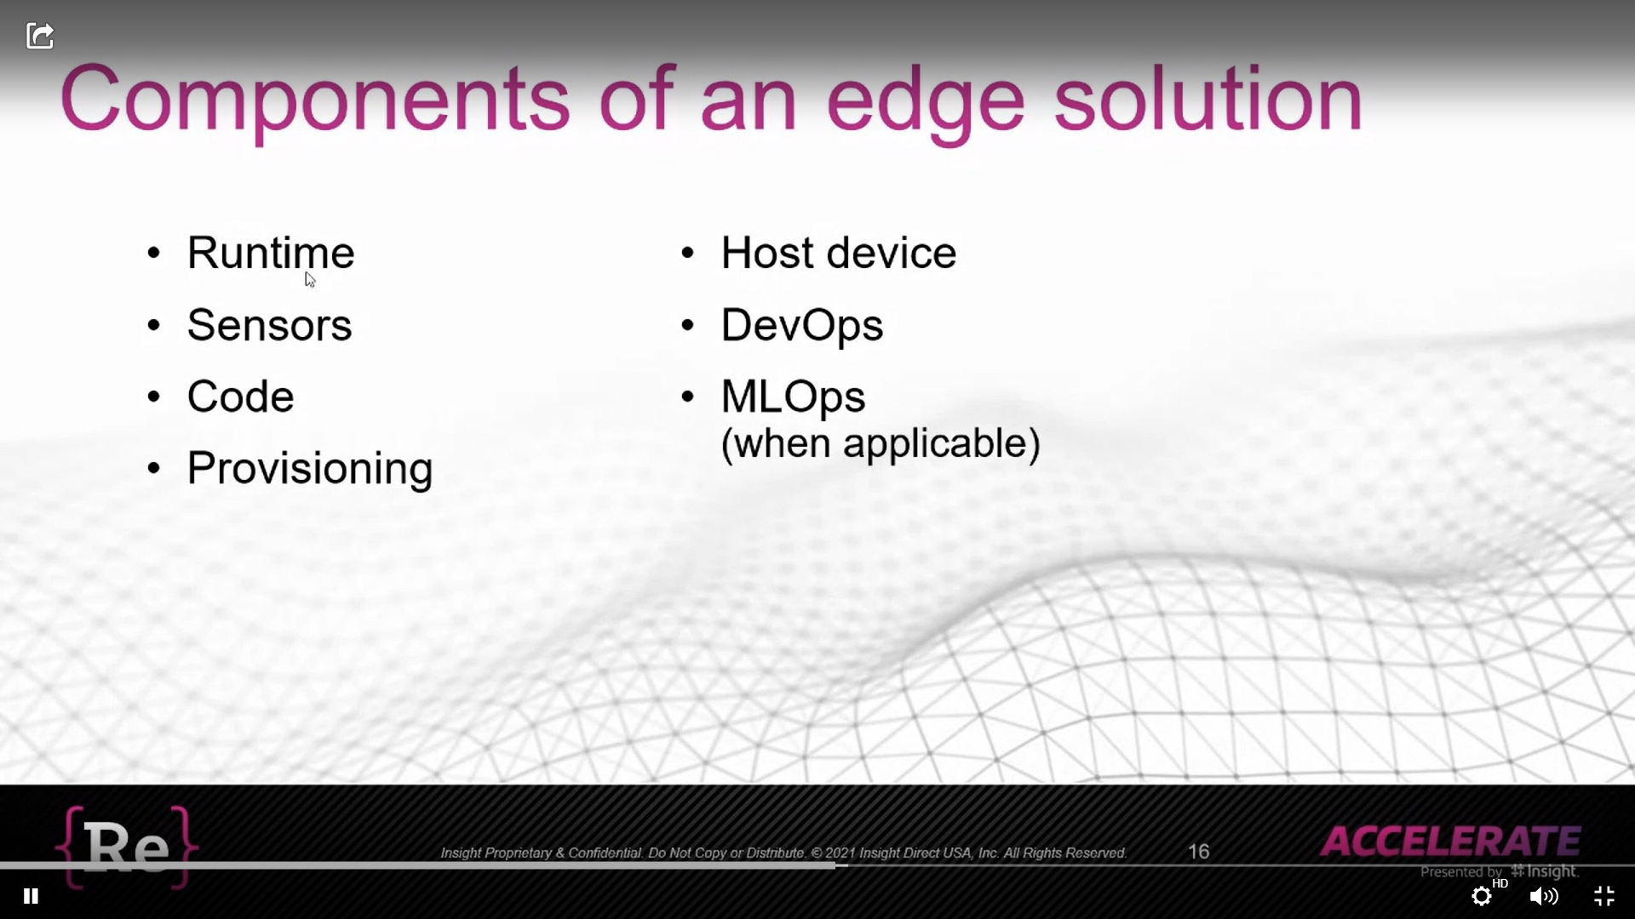

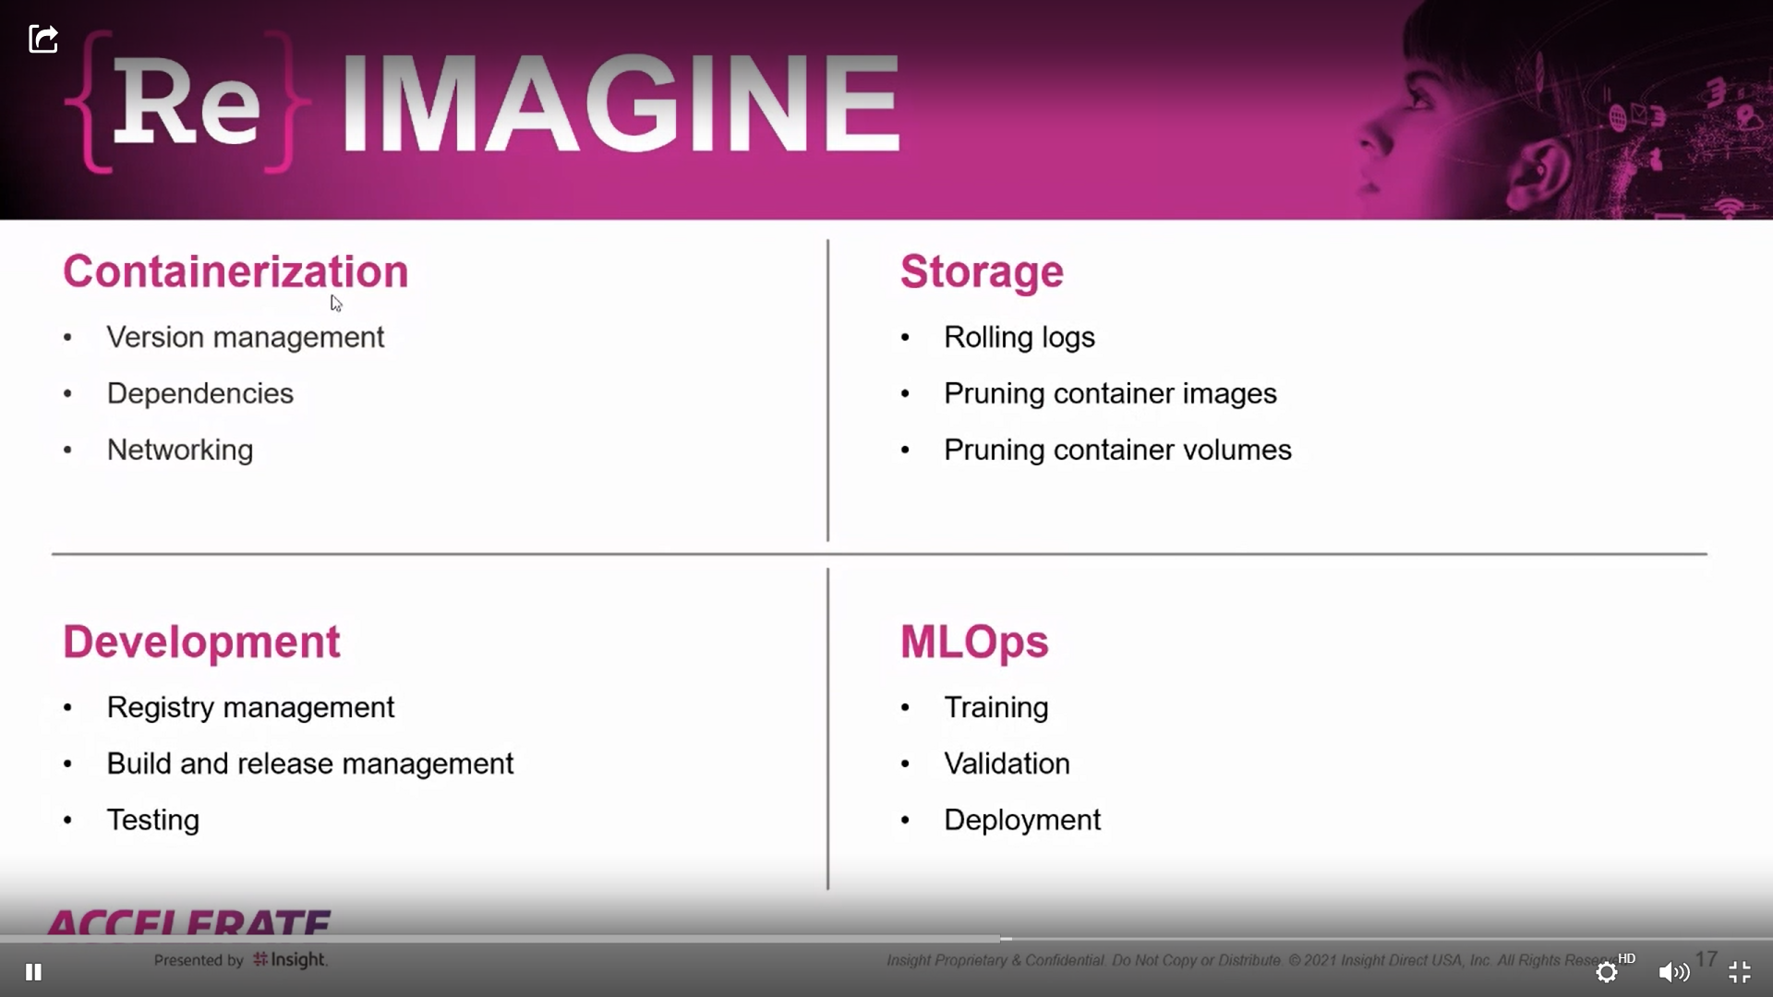

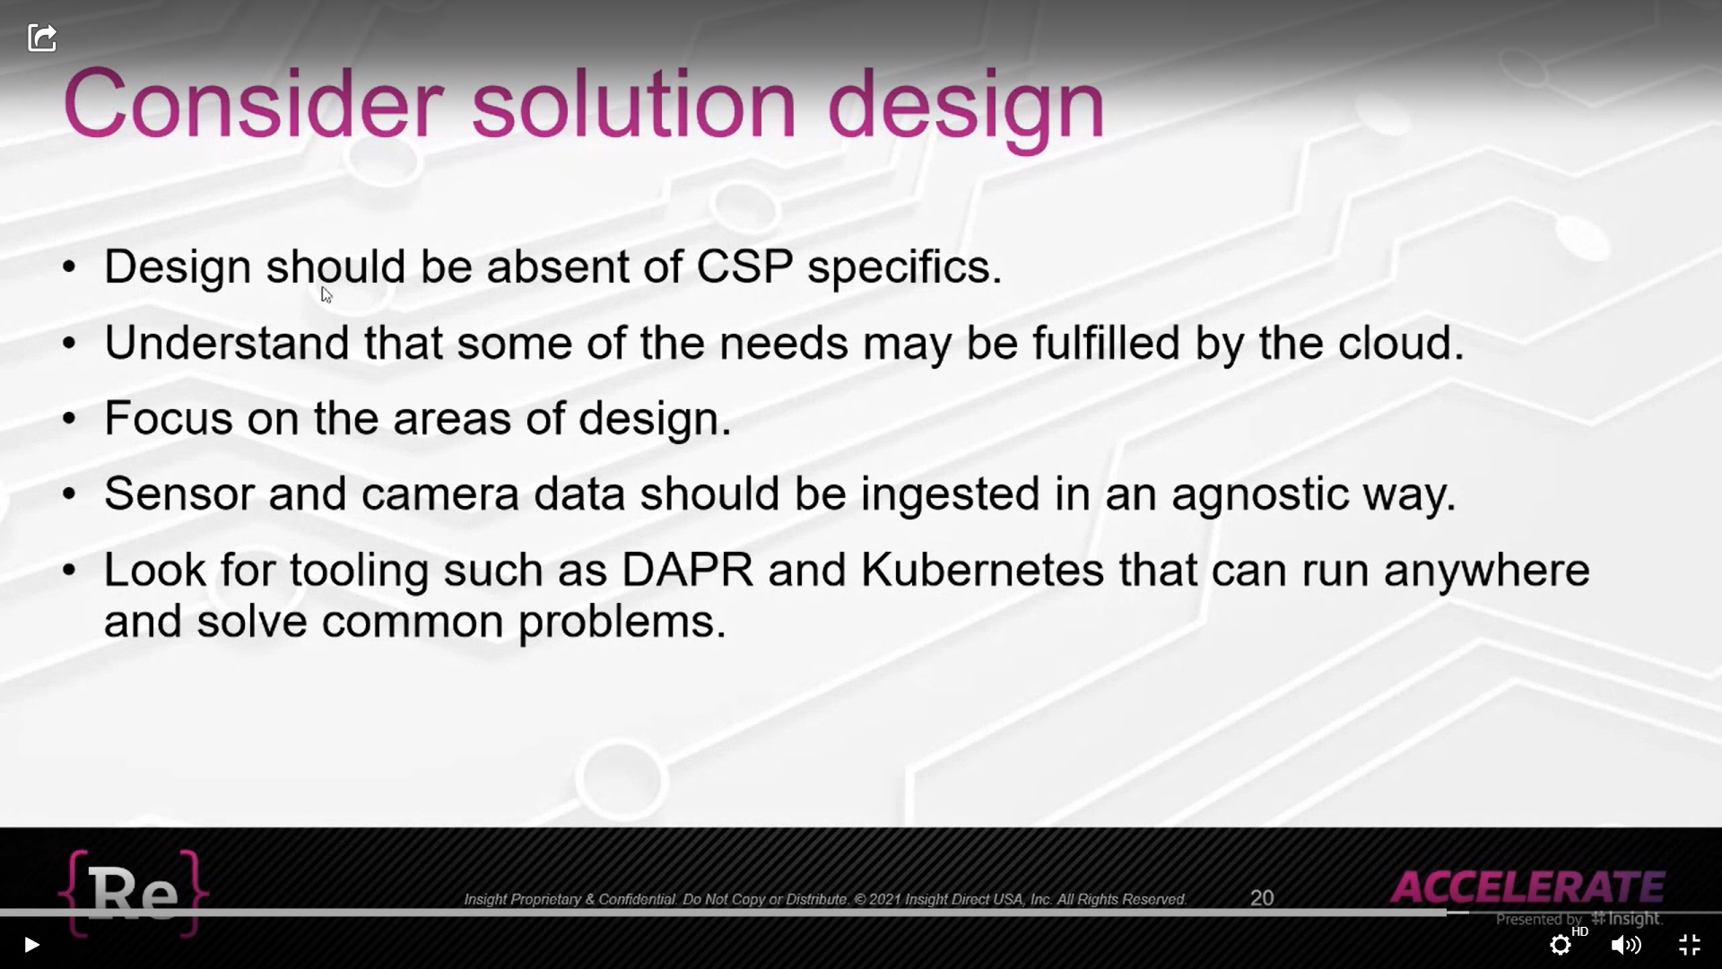

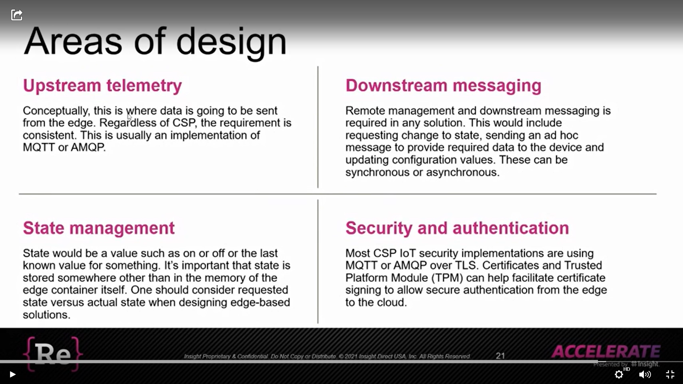

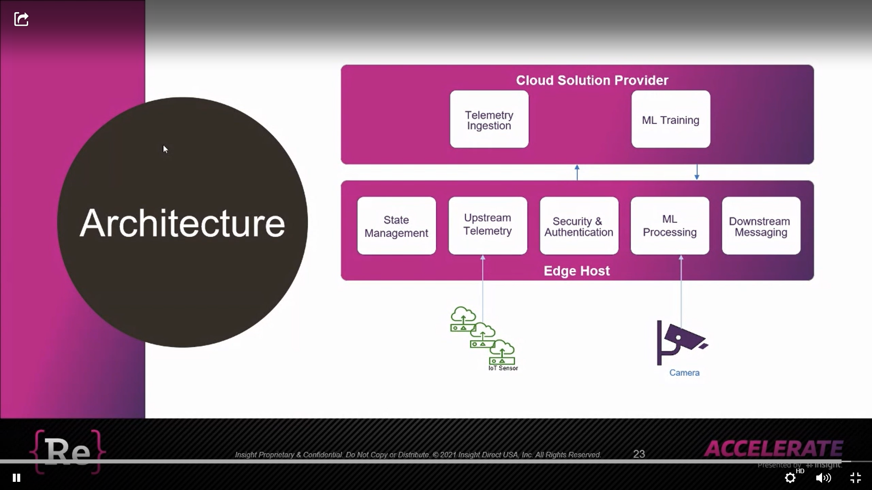

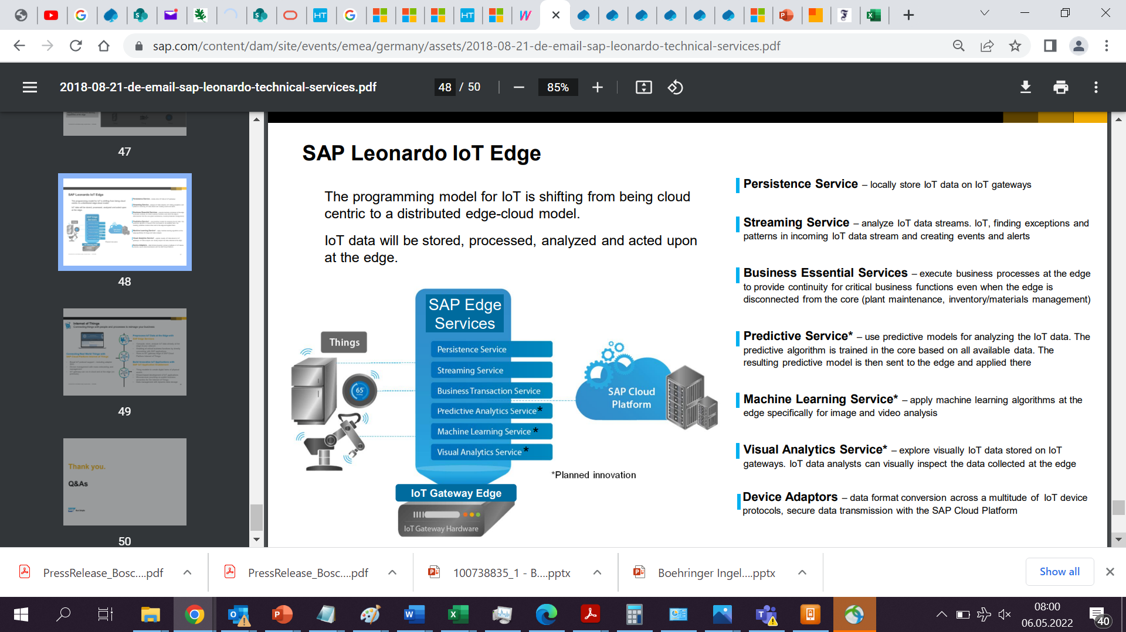

AI is planned innovation 2018

